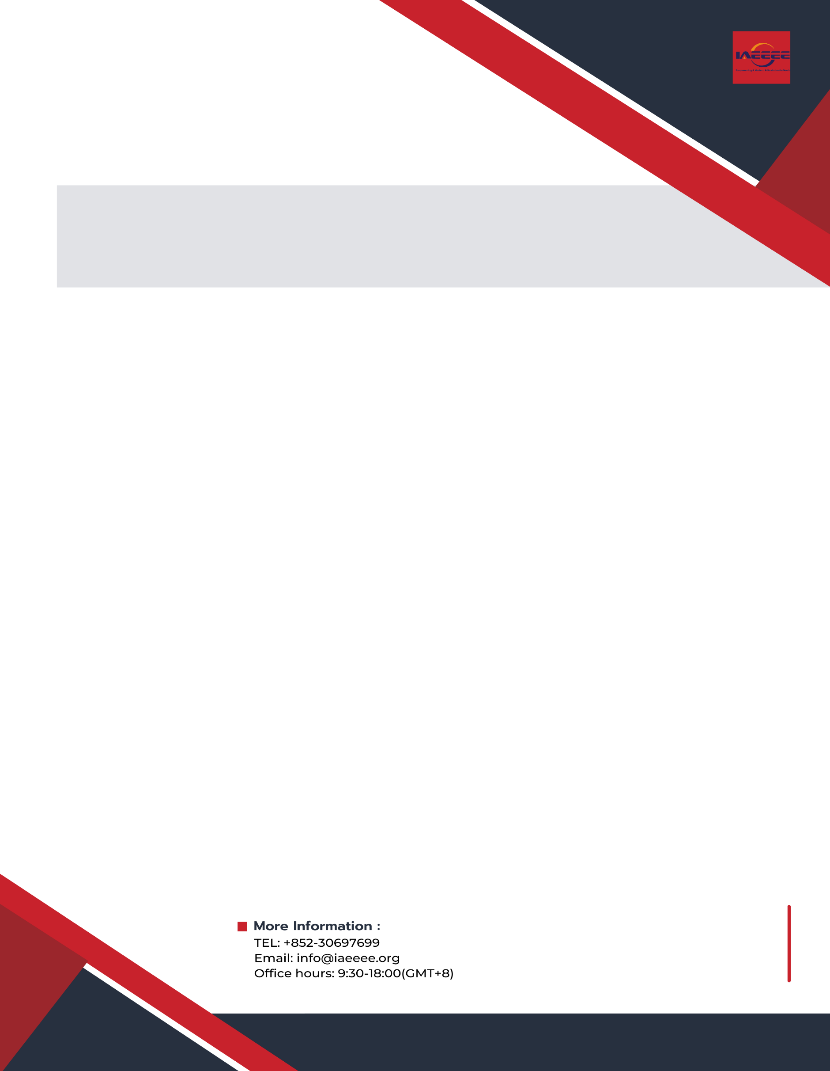
CEVVE 2022
Conference
Registration
Form

Kindly complete the following form to register for the CEVVE 2022 Conference.

NOTE: Please make sure to submit these documents to conference email cevve@iaeeee.org.
1. final paper (doc. and pdf.) 2. completed registration form 3. payment proof

PERSONAL DETAILS (*required)
*Title | Prof. □ | Assoc. Prof. □ |  | Asst. Prof. □ |  | Photo Here
 | Dr. □ | Mr. □ |  | Ms. □
 | Lecturer □ | Ph.D Candidate □ |  | Postgraduate □
*Name
*Affiliation
*Nationality
*Phone Number
*Email
*Emergency Contact  (Second author) | (Name & Mobile)
Postal Address
Catering  (Onsite Conference)  (September 29)√ | Lunch □ |  |  |  | Dinner □
Special dietary√ | Diabetic □ |  | Vegetarian □ |  | Halal food □ |  | Other □  please specify:
Special requirements
(if any)

PAPER INFORMATION
*Paper ID |  |  |  |  |  | *Paper Pages |  |  |  | *Additional Page
*Paper Tile
*Authors
*Will you attend the conference |  |  |  |  | Yes □ |  |  |  |  |  | No □
*Presentation Type√ |  |  | Oral □ |  |  |  | Poster □ |  | Pre-recorded Video □ |  |  | Live Video □
Student ID No. (student only)
IAEEEE Member No.(member only)
*Receipt Issued to (usually refers to the person who paid the fee or the organization which will sponsor you to attend conference. If you will use the receipt for reimbursement purpose, we advise you to put your organization/company/affiliation name below):
REGISTRATION FEE (by US dollar)
ONSITE CONFERENCE
Category | Early  (Until Apr. 20, 2022) | Regular  (Until May 25, 2022) | Late  (After May 25, 2022) | On-site  (Sep. 28-30, 2022) | Your Choice
Member Author | 480 USD | 500 USD | 530 USD | 580 USD
Author | 500 USD | 530 USD | 580 USD | 610 USD
Student Author | 450 USD | 480 USD | 520 USD | 550 USD
Presentation only | 400 USD | 450 USD | 480 USD | 520 USD
Listener | 350 USD | 400 USD | 450 USD | 500 USD
 | ONLINE CONFERENCE
Member Author | 390 USD
Author | 420 USD
Student Author | 380 USD
Presentation only | 300 USD
Listener | 200 USD

 | OTHERS
Networking Event | TBD
Academic Visit Optional | TBD
Extra Page/Per page | USD 70
Extra Paper Upload | USD 370
Extra Banquet Ticket | USD 50
·Notice
·Ordinary paper page is 5-14 pages per paper. If the paper exceeds 5 pages, the additional pages will be charged.
·All papers will be published online.
·For "No shows", registration fee is nonrefundable and the organizing committee shall not be liable for any compensation or refund.
·Shall the conference is delayed or prevented (directly or indirectly) by the reasons of natural disasters, war, strike(s), epideic or any other events which could not be controlled, the organizing committee shall be under no liabilities. The organizing committee reserves the right to change the conference date, venue or form of the conference (online or on-site).
·Cancellation policy: If a registrant is unable to attend CEVVE 2022, they may substitute, by arrangement with the conference organizer, someone else to attend the conference, or transfer their participation to another conference in IAEEEE conference portfolio. If the aforementioned solutions are not applicable to the registrant, the following policies of cancellation and refund apply.
Up to 90 days prior to the conference date:
70% refund of the registration fees paid
Less than 90 days, but more than 60 days prior to the conference date:
60% refund of the registration fees paid
Less than 60 days, but more than 30 days prior to the conference date:
50% refund of the registration fees paid
Less than 30 days prior to the conference date:
No refund
Please note: The cancellation and refund request must be made formally through email to cevve@iaeeee.org.
·Our payment system will not charge any extra fee, but the credit card payment may incur currency exchange charge which is charged by payers' bank, it should be borne by payers.
·Full registration fee covers (Onsite authors only): publication fee +meeting sessions on September 28-30 +2 coffee breaks, 1 lunch, 1 dinner on September 29+ conference kits.
PAYMENT INFORMATION
Online payment linkage (*VISA /Master is available. No handling fees, please calculate the amount and pay):
https://meeting.yizhifubj.com/web/index.action?meetingId=573
Please fill your E-mail address used for the payment and the Confirmation Number you received after paid.
E-mail:
Confirmation Number:
*As the system will intercept the email address for multiple payments, it is recommended to use different email for each payment.

IAEEEE MEMBER APPLICATION
Join IAEEEE now to qualify for member registration rates.
Please compile and return the Membership Form along with your CV to membership@iaeeee.org. Your application will be processed in 5 working days.
Contact us at IAEEEE LinkedIn:
IAEEEE LinkedIn

CEVVE 2022 Organizing Committee
China Hefei

